Brian Lambert

STA 404

Module 7 Homework

1. **Map of my home state (Ohio) with my town (Hamilton) labeled**

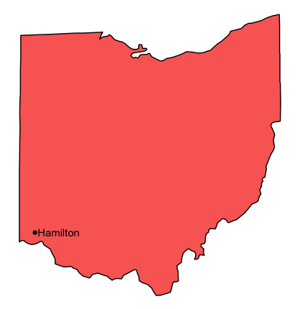

1. **Choropleth map of US, states shaded by % with BS or higher degree**

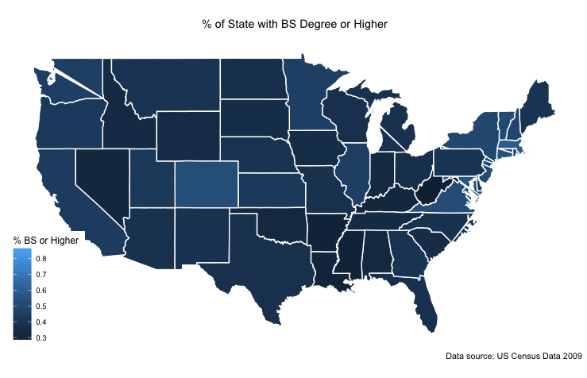

**CODE:**

# ###############################################################

# #

# Author: Brian Lambert #

# Name: lamberbr_module7.R #

# Description: Plots of home state / town and choropleth map #

# of the USA and shade each state with the % possessing a BS #

# degree or higher. #

# #

# setwd(“/Users/brianlambert/Desktop/STA404/Module 7”) #

# #

#################################################################

library(tidyverse)

library(gapminder)

library(ggplot2)

library(forcats)

library(dplyr)

library(maps)

library(ggplot2)

library(ggmap)

library(mapproj)

library(ggthemes)

library(mapdata)

library(rworldmap)

library(choroplethr)

#========================== Home State and Town ==========================

# source: Krallman dashboard utiliized similar methods so I was able to repurpose

# parts of the code for these two plots

# long and lat data for every state

states_map <- map_data("state")

str(states_map)

unique(states_map$region)

# filter for just ohio long and lat

ohio_map <- subset(states_map, states_map$region=="ohio")

unique(ohio_map$region)

# plot Hamilton country based on long and lat I found online

Hamilton_County <- data.frame(long=-84.5641, lat=39.2355)

# plot of Ohio with Hamilton county labeled

ggplot()+

geom_polygon(data=ohio_map, aes(x=long,y=lat,group=group,fill=region),fill="#FA6A64", colour="black") +

geom_point(data=Hamilton_County,aes(x=long,y=lat)) +annotate(geom="text",x=-84.5641,y=39.2355,label=" Hamilton",adj=0, color="black") +

coord_map()+

theme_nothing()

#========================== US BS Degree or Higher Distribution ==========================

# census data was found on wikipedia, copied into excel, cleaned in excel to make merging easier

# with the state long and lat data, saved as csv

census = read.csv("/Users/brianlambert/Desktop/STA404/Module 7/Bs_census_data.csv", header = T)

state_map = map_data("state")

# merge state long and lat data with the census data for % BS or higher degree

state_map = merge(state_map,census, by ="region", all.x = T)

# map of USA with each state filled witht % BS or higher degree

ggplot(state_map, aes(x=long, y=lat, group=region, fill=bsOrHigher))+

geom_polygon(col="white")+

coord_map() +

theme_map() +

labs(title = "% of State with BS Degree or Higher",

caption = "Data source: US Census Data 2009",

fill="% BS or Higher") +

theme(plot.title = element_text(hjust = 0.5))